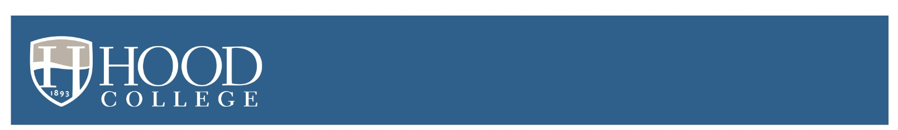

Fall 2022 Accepted Student Checklist

- Plan a visit at hood.edu/visit. (Whether it’s your first visit or you’re coming back, virtual or in-person, we have lots of opportunities for you to get to know us better.)

- If you have not already done so, visit https://studentaid.gov to obtain your FSA ID and complete your 2022-23 FAFSA as soon as possible. We need this information to provide you with a complete financial award package.
Need help with the FAFSA? Visit hood.edu/financialaidresources.

- Save the date for one of our Accepted Students’ Days –
Saturday, March 26, 2022 or Saturday, April 2, 2022.
Details and invitation to follow!

- Commit to Hood by submitting your $350 enrollment deposit at hood.edu/imablazer
NOTE: This non-refundable deposit must be submitted on or before May 1, 2022 to secure your place in the fall 2022 entering class.

- Watch for an email with instructions to access your student portal!

An updated checklist including items required prior to the start of classes will be sent upon receipt of the $350 enrollment deposit.

