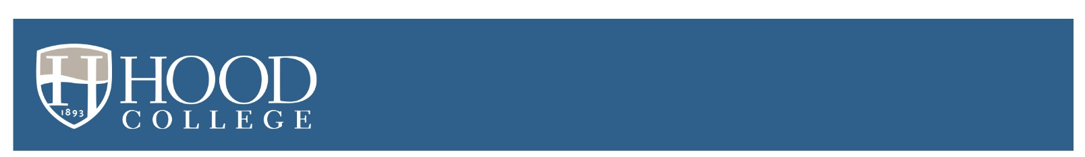
Fall 2022
Deposited Student Checklist

- Set up your Hood College email account. Your username and password were sent in the letter confirming payment of your enrollment deposit. If you need this information to be re-sent, email admission@hood.edu. Once you receive your username and password, set up your email as soon as possible, your temporary password expires in 90 days. Check your Hood email often, we will use this for lots of important communication throughout your enrollment at Hood.

- Complete and submit your enrollment agreement. Download at hood.edu/accepted and email the signed agreement to admission@hood.edu.

- Sign and return the official award notification you received from financial aid at hood.edu/award.

- Download and submit all required medical and immunization forms at hood.edu/medicalforms. These forms can be completed up to a year before you begin classes at Hood, so don’t wait, you can do it now!

- Complete math, English and global language placement tests, if you will not be bringing in college credit in these areas. More information about placement tests is available at hood.edu/placementtest.

- Register for classes. All new students will attend an Advising and Registration Day over the summer. The Student Success Center will begin scheduling these sessions in April. For additional advising and registration questions, contact studentsuccess@hood.edu or 301-696-3569.

- Students living on campus: The Office of Residence Life will email housing information to your Hood email, but contact residencelife@hood.edu with questions or to request housing forms.

- Submit your official SAT or ACT scores (for general reporting purposes only) to admission@hood.edu.

- Submit a request to all previous institutions to have your official transcript(s) sent to Hood before the start of the semester. Failure to submit final transcripts will prevent future course registrations.

Steps to order your transcript(s):

- Contact your high school to order an official transcript and have it sent to Hood College directly from the institution.
- If you took dual enrollment courses, please contact that college/university to order an official transcript and have it sent directly to Hood College. We need your official high school transcript as well as an official college transcript in order to apply credit to your Hood record.
- Transfer students must order official transcripts from all previous colleges/universities and have them sent directly to Hood College.
- For quickest transcript delivery, please request an electronic official transcript. You may be able to find ordering information online at your previous institution.

- Apply for academic or housing accommodations (if necessary). To ensure a smooth transition, begin this process as soon as possible. Information and forms are available at hood.edu/accessibilityservices.

Additional information including important dates and deadlines will be sent to your Hood email address.

