Initiatives to Fight Food Waste
By: Sarah Buckley

All around the world, interesting and unique initiatives and solutions are being developed to fight food waste. In this blog entry, you will learn various mitigation strategies being used around the world and why municipal composting is a great idea (with challenges).
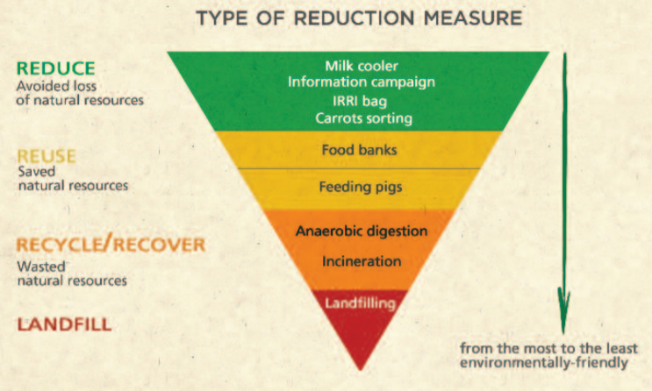
Strategies to Mitigate
The Food and Agriculture Organization of the United Nations (FA O) issued a report in 2014 called Mitigation of Food Waste: Societal Costs and Benefits. It examines several case studies with different mitigation techniques. Few of these measures are mainstream yet, but they represent some pretty unique and interesting measures to reduce food waste.
- Landfilling: Food is one of the largest categories that makes up landfills, and as the food rots it releases methane, a very potent greenhouse gas.
- Incineration: Burning food waste is better than burying it, but it still releases lots of carbon dioxide.
- Anaerobic digestion means to allow microorganisms and bacteria to break down food. This releases still releases greenhouse gases, though less than landfills or incinteration.
- Feeding pigs: While this is great for areas close to farms, it may not be ideal for cities. It also has the added bonus of freeing up resources from pig feed. However, there are many laws against pigs eating meat and this would require adequate sorting.
- Food banks were examined in Germany and Italy. Logistics proved to be the main issue, as some food was in danger of spoiling. Otherwise there were few issues.
- The International Rice Research Institute (IRRI) created an airtight and gastight ‘superbag’ for rice. Rice is a very carbon and water intensive crop, so finding out ways to prevent rice from spoiling has been an effective reduction measure in Asian countries.
- The information and communication campaign was studied in the United Kingdom. There are several existing food waste prevention programs, though the case study used a scenario in which these programs did not exist. The study found that overall demand for food decreased.
- Carrot sorting machines: These save over 400 tons of carrots annually, which brings down the 30% carrot loss rate significantly. Case study was in Switzerland.
- Milk coolers: About 15% of milk is lost every year by Kenyan dairy farmers. Cooling machines in Kenya can hold up to 1,000 liters of milk, and this will be enough to save almost all of the 15% losses!

Municipal Composting
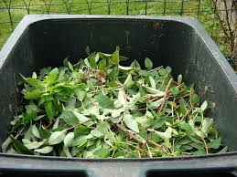
Whew, that was a long section! If you paid attention, you may have noticed that I didn’t mention composting. Composing is a great option if you have the space and time at home, but what about for the people who don’t? Municipal composting was examined as a mitigation strategy by the World Bank in September 2016. Here’s a link to their report. Composting is growing in all sectors. It’s a great way to divert waste from landfills. However, for municipal composting programs to work they need a few things. First, they need government and policy support. In addition to loans and subsidies, policies must be compost friendly. A big barrier some groups are struggling with is not being allowed to sell organic materials as livestock feed. The key to making municipal composting work long-term is for the company to have a diversified revenue stream through collection fees, selling of compost and organic material, and subsidizing the use of compost over chemical fertilizer.
According to the report, Europe is a huge success story with organics recycling. 42% of organic waste in Europe is recycled through anaerobic digestion and composting! There are over 2,500 organic waste treatment facilities throughout Europe. Their programs are partly so successful because of the high carbon taxes in place. Composting is now a very economically attractive option, and there isn’t just one way to do it. Some programs are centralized, some are decentralized, and others emphasize at home composting or collection programs.
The United States would be successful with a municipal composting program because it is so flexible, but it will be a long time before organic recycling is as popular with traditional recycling. It would be very convenient for a third bin to be given to US families for the sole purpose of organic material and use the same existing trash and recycling routes. US laws make putting organic materials in landfills convenient, and there isn’t much support or attention given to food by elected officials. In the meantime, see if you can subscribe to a program in your area!
Check out this website from the Environmental Protection Agency to see a list of food waste programs by area. I hope you enjoyed our blog series about food waste! Keep taking steps to reduce the food waste of you and your family. Together, we totally got this! Check out these links below to find out more information about fighting food waste:
https://foodtank.com/news/2015/01/twenty-one-inspiring-initiatives-working-to-reduce-food-waste-around-the-wo/
https://www.epa.gov/sustainable-management-food/wasted-food-programs-and-resources-across-united-states
Literature Cited
Andrews, E. (2016, November 16). 21 Inspiring Initiatives Working to Reduce Food Waste Around the World. Retrieved from https://foodtank.com/news/2015/01/twenty-one-inspiring-initiatives-working-to-reduce-food-waste-around-the-wo/
Environmental Protection Agency. (2020, April 29). Wasted Food Programs and Resources Across the United States. Retrieved from https://www.epa.gov/sustainable-management-food/wasted-food-programs-and-resources-across-united-states
Food and Agriculture Organization of the United Nations. (2014). Mitigation of Food Wastage: Societal Costs and Benefits. Retrieved from http://www.fao.org/3/a-i3989e.pdf
World Bank Group. (2016, September). Sustainable Financing and Policy Models for Municipal Composting. Retrieved from http://documents.worldbank.org/curated/en/529431489572977398/pdf/113487-WP-compostingnoweb-24-PUBLIC.pdf

