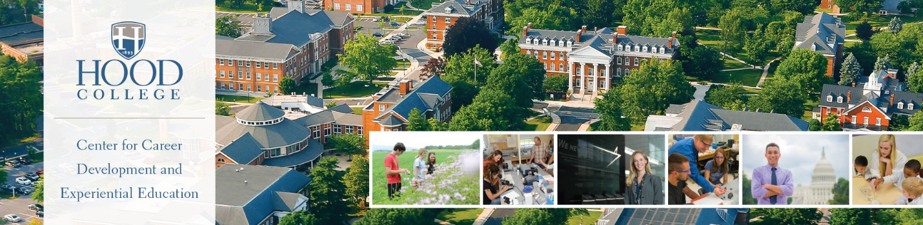

CAREER CENTER RESOURCES FOR STUDENTS
Apple Building, 2nd Floor, (301) 696-3583, careers@hood.edu

CAREER DEVELOPMENT:
- One-On-One Appointments – Students can meet with a career counselor to explore career options, internship and job search strategies, preparation for interviews, and networking.
- Essential Documents – Through one-on-one appointments, students receive assistance creating individualized resumes, cover letters, and reference pages. Students also receive assistance with personal statements for graduate schools and other unique document creation.
- Events and Programs – Career Center staff offer classroom presentations on a variety of topics. Annual events include career fairs, an etiquette dinner, employer recruitments, and networking activities.

CAREER EXPLORATION:
- Focus2 – Online career assessment that students may take on any computer, at their own pace, and at any time. Provides results in five areas of career including personality, work interests, values, skills, and leisure activities. Students may take this assessment during and after their time at Hood and may repeat the assessment to understand changes in their career interests.
- Myers Briggs Type Indicator (MBTI) and Strong Interest Inventory – Advanced career assessments recommended for junior, senior, and graduate students. Provides depth exploration of career interests based on personality attributes.
- What Can I Do With This Major? – Designed to show students the many ways they can utilize their studies in different career fields. This resource explores more than 50 majors and shows what careers most naturally flow from these areas and different work settings to consider.

INTERNSHIP AND JOB SEARCH:
- HANDSHAKE - This online resource houses options for students searching for internship and job opportunities including public and private companies, governmental agencies, and nonprofit organizations seeking Hood Students.
- CAREERSHIFT – Job aggregator and an organizational tool allowing students to search by keyword and company. Students can search for contacts within companies and track their progress with applications and save opportunities.

INTERVIEW ASSISTANCE AND NETWORKING:
- MOCK INTERVIEWS – Students meet one-on-one with a career counselor who will ask interview questions, review student responses, offer strategies for answering difficult questions, and provide written feedback. Hood alumni often participate in special mock interviewing events.
- ALUMNIFIRE – Online networking platform that allows currently enrolled students to meet alumni from a wide variety of fields and industries to learn about roles, pathways to employment, and unique opportunities.

Learn more and link to Career Center resources at https://www.hood.edu/campus-community/catherine-filene-shouse-center-career-development-experiential-education/resources.

