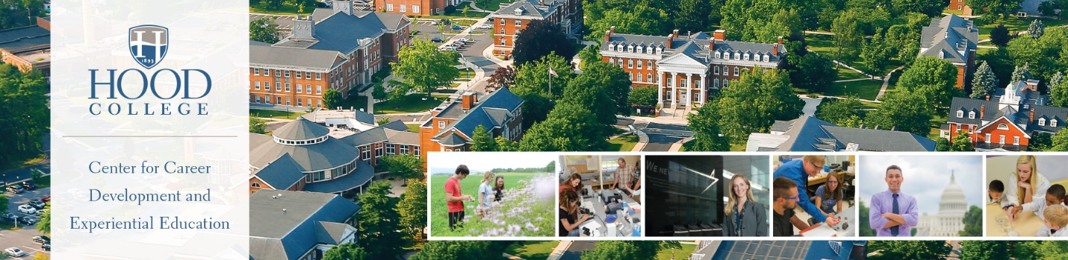

CAREER CENTER RESOURCES FOR STUDENTS
Apple Building, 2nd Floor, (301) 696-3583, careers@hood.edu

CAREER DEVELOPMENT:
- One-On-One Appointments – Students can meet with a career counselor to explore career options, internship and job search strategies, preparation for interviews and networking.
- Essential Documents – Through one-on-one appointments, students receive assistance creating individualize resumes, cover letters, and reference pages. Student also receive assistance with personal statements for graduate schools and other unique document creation.
- Events and Programs – Career Center staff offer classroom presentations on a wide variety of topics. Annual events include career fairs, etiquette dinner, employer recruitments, and networking activities.

CAREER EXPLORATION:
- Focus2 – Online career assessment that students may take from at their own pace and at any time. Provides results in five areas of career including personality, work interests, values, skills, and leisure activities. Students may take this assessment during and after their time at Hood and may repeat the assessment to understand changes in their career interests.
- Myers Briggs Type Indicator (MBTI) and Strong Interest Inventory – Advanced career assessments recommended for junior, senior, and graduate students. Provides depth exploration of career interests based on personality attributes.
- What Can I Do With This Major? – Designed to show students the many ways they can utilize their studies in different career fields. This resource explores more than 50 majors and shows what careers most naturally flow from these areas and different work settings to consider.

INTERNSHIP AND JOB SEARCH:
- HANDSHAKE - This online resource houses options for students searching for internship and job opportunities including: Public and private companies, governmental agencies, and nonprofit organizations seeking Hood Students.
- NACELink – National Association of Colleges and Employers Database. National database of opportunities available only to subscriber schools.
- CAREERSHIFT – Job aggregator and organizational tool allowing students to search by key word and company. Students can search for contacts within companies and track their progress with applications and saved opportunities.

INTERVIEW ASSISTANCE:
- MOCK INTERVIEWS – Students meet one-on-one with a career counselor who will ask interview questions, review student responses, offer strategies for answering difficult questions, and provide written feedback. Hood alumni often participate in special mock interviewing events.
- INTERVIEW STREAM – Computer based program that allows students to record themselves responding to interview questions and to self-critique their performance. Recordings may be reviewed by faculty members and others who can contribute to improving the student’s abilities. This interview practice tool also mirrors the procedure and outcome of a Skype interview situation.

