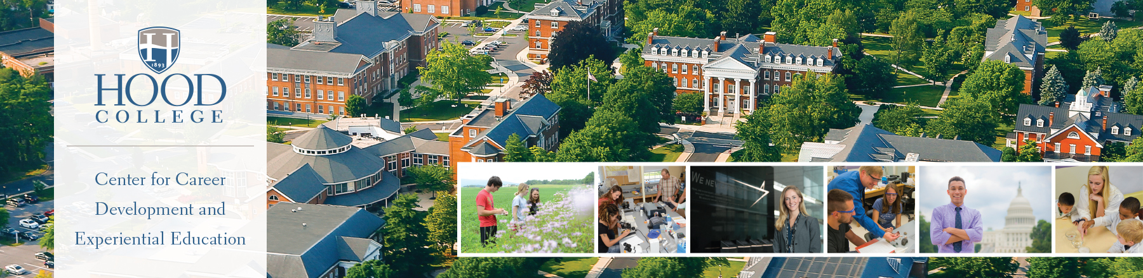

Freshman Career Planning Checklist

Strive for a strong GPA.
- Your GPA will determine if you will be able to pursue future careers goals. Many of the prized internships will require a GPA of 3.0 or higher. Medical and law school will want a GPA of 3.5 or higher. Now is the time to establish a good GPA and keep it going. Go to class, schedule time to study, know what is expected of you and follow through. Meet with your professors if you need help and begin to build that mentor relationship. If you are struggling with your classes, mathematics, or writing, make an appointment to use Hood’s tutoring services in the Center for Academic Achievement (CAAR) on the first floor of the Hodson Beneficial Library.

Try out different courses.
- Freshman year is a good time to take courses in areas you would like to explore further.

Get involved on campus.
- Getting involved on campus has many benefits. You will make new friends, learn new skills, and feel more connected to your school. It may also lead to ideas about career choices! Hood offers an array of intramural sports, and more than 60 clubs and organizations encompassing every interest. Check out the Student Organization Directory to find a student group which appeals to you. More information can be obtained through the Office of Student Life on the second floor of the Whitaker Campus Center.

Volunteer in the community.
- There are dozens of reasons why you should volunteer; finding a purpose, meeting new people and learning new skills are just a few. The Career Center can help you identify volunteer opportunities through our website and a Volunteer Fair held each fall and spring semester. For more information, call (301) 696-3583 or visit the Career Center on the second floor of the Apple Building.

Learn about yourself, majors and future careers.
- Research the majors offered at Hood. Read the required coursework and determine what is of interest to you. Use FOCUS-2, the Career Center’s online career planning system to take a personality assessment, explore majors and potential careers. FOCUS-2 can be found at https://www.hood.edu/centerforcareerdevelopment/. Access code is: blazer.

Prepare or update your résumé.
- You may already have a résumé, and your freshman year is a great time to update it with new coursework, campus and volunteer activities, and part-time jobs. If you don’t have a résumé, there’s no better time to begin writing one! Utilize the Career Center’s résumé tutorial to get started and refer to a freshman résumé sample to help you in the process.

Attend Campus events.
- Plan to make an appearance at as many campus events that may help in determining your future plans. If a possible employer is on campus for an information session, stop in and hear what they have to say. Social Visionary Series offer opportunities for students and community members to hear about the world around us and how you can make a difference in the future. Stay abreast of Career Center event through our website and our online career management platform Handshake.

Think about the best way to spend your summer.
- There are several options to consider for the summer: volunteer, internships, summer jobs and study programs.

