How to Search for Classes Online
- Start by going to the main Hood College Graduate School webpage at: www.hood.edu/graduate

- Click the “Current Students” link at the top of the page.

- Click the “Self Service” link in the ApLinks column.
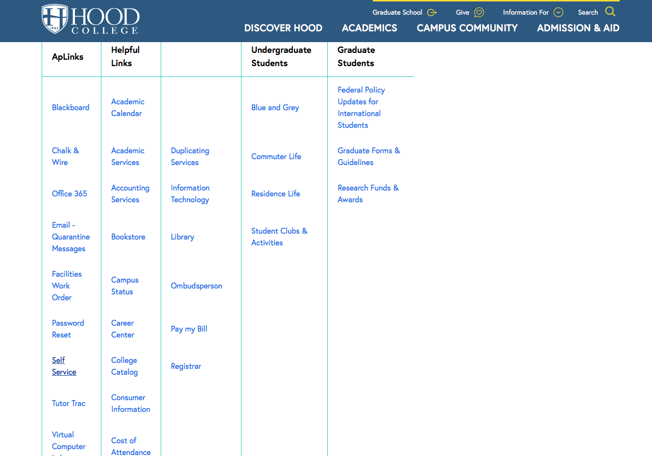
- Click the “Search” tab at the top of the screen.

- Then click the “Section Search” option under the “Search” tab.

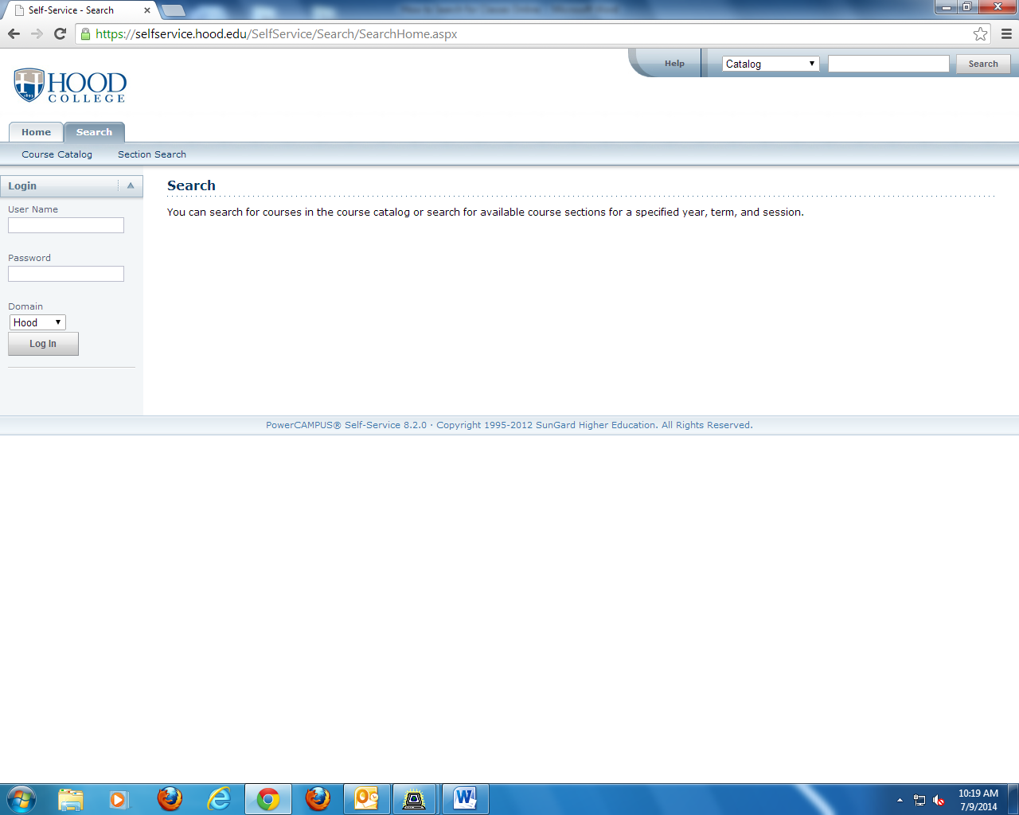

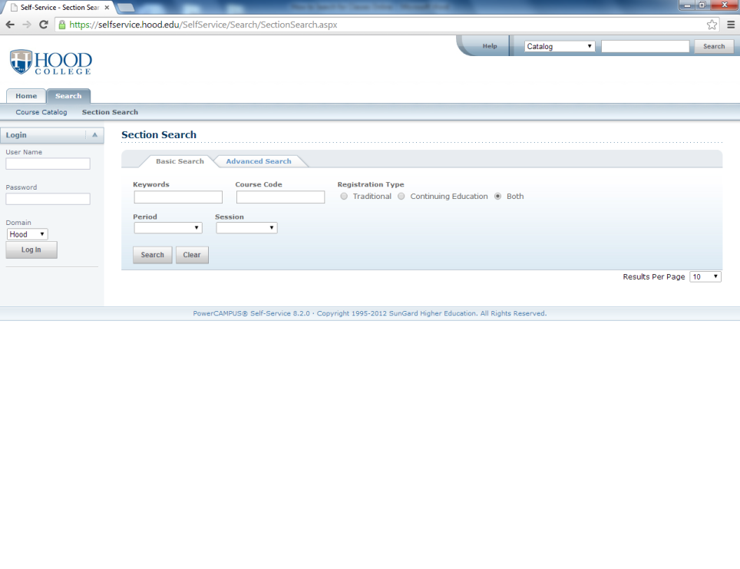
- Select the “Advanced Search” option.

- Use the “Period” dropdown menu to choose the appropriate year/term. Use the “Program” dropdown menu to select “Graduate”, then fill in other cells with desired information to search the class listings.
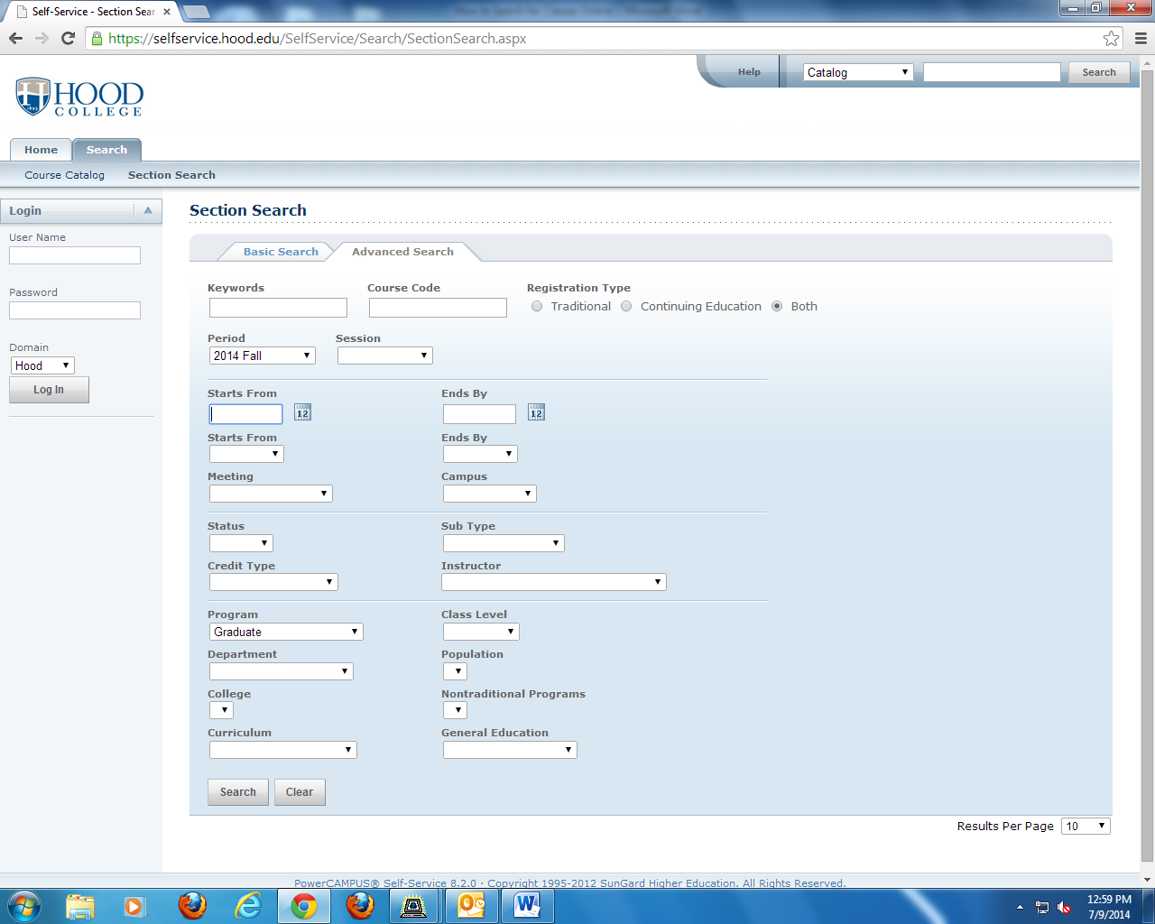

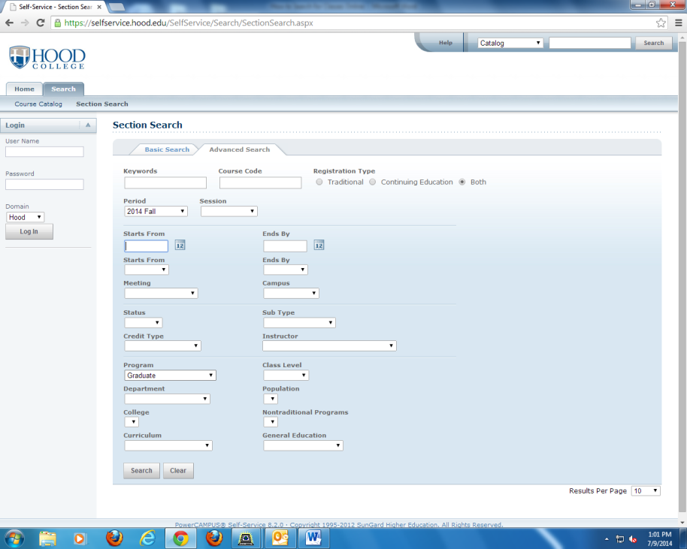
- Lastly, click the search button at the bottom of the screen.

- The results will then be displayed on the screen.
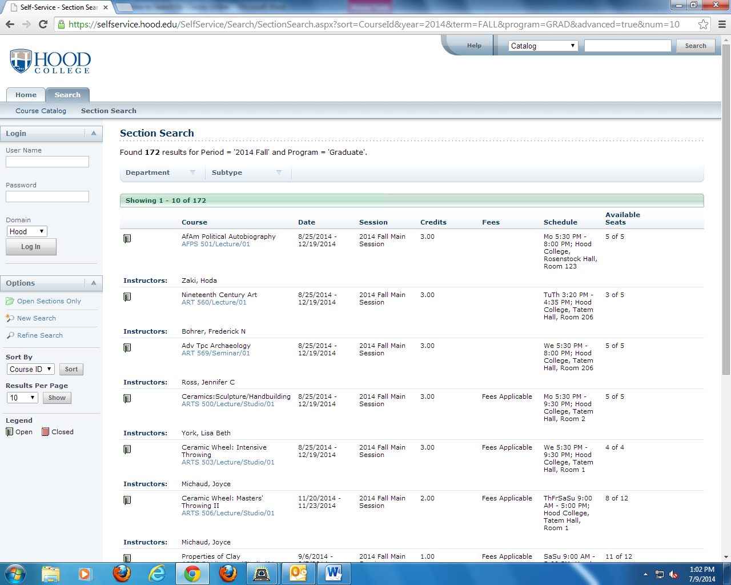

- You can then move on to other pages by using the buttons at the bottom of the screen.
