Campus Clear Installation Instructions
Revised 08/06/2020

For Apple and Google Mobile Devices

- Download and install the CampusClear App:

Apple App Store Download Link:

https://apps.apple.com/app/campusclear/id1516163872?l

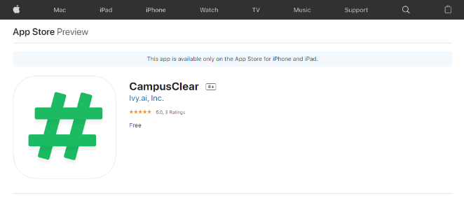

Google Play Store Download Link:
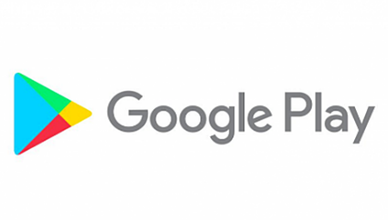
https://play.google.com/store/apps/details?id=com.campusclear

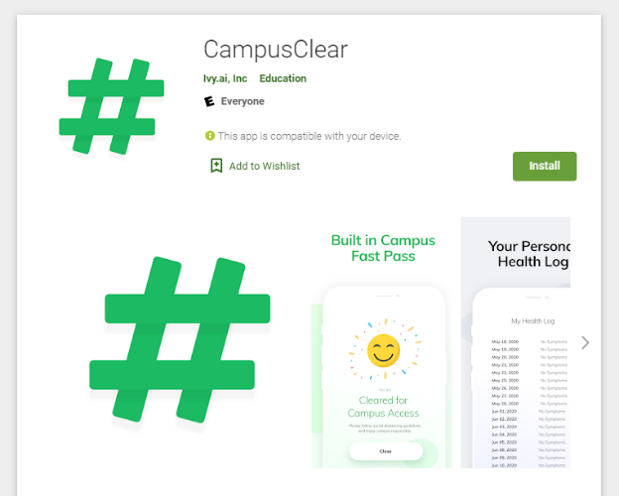
- Launch the CampusClear App and review the following terms and conditions.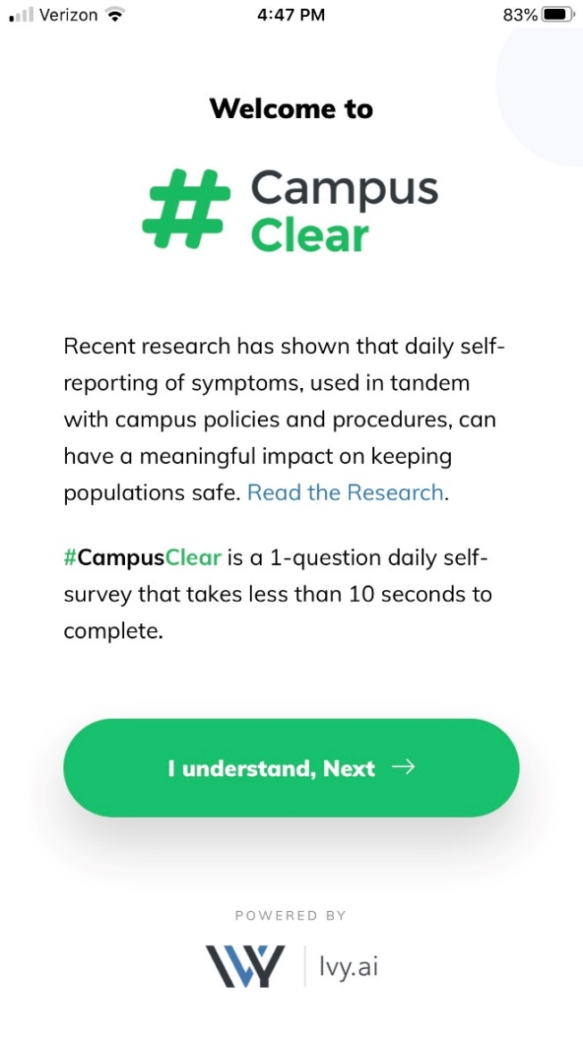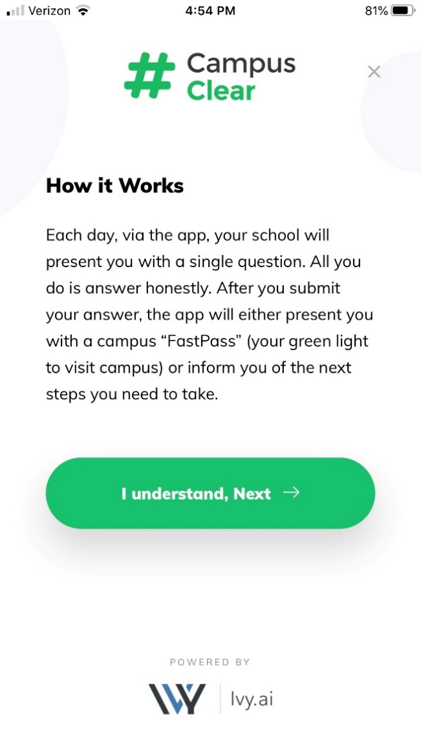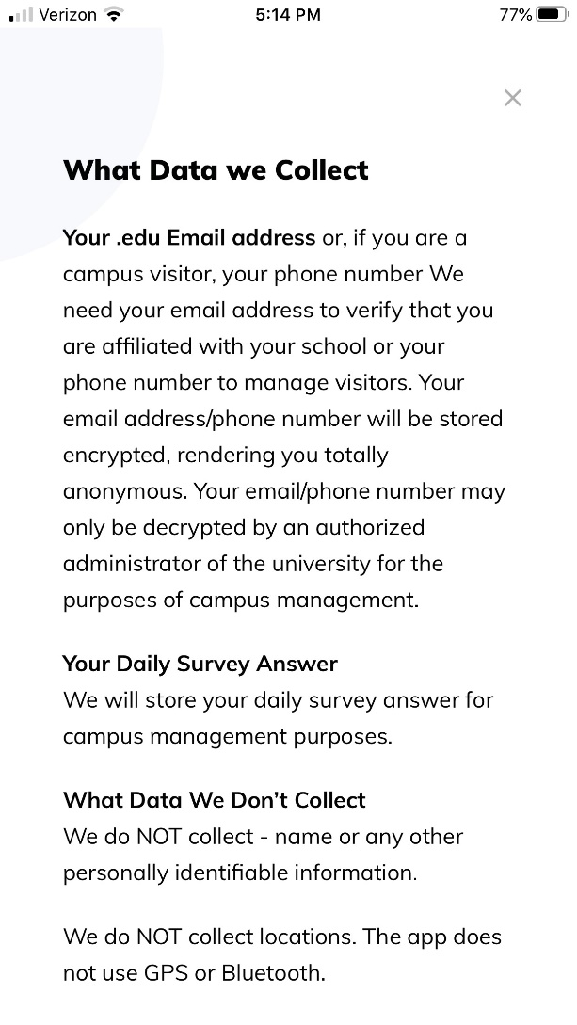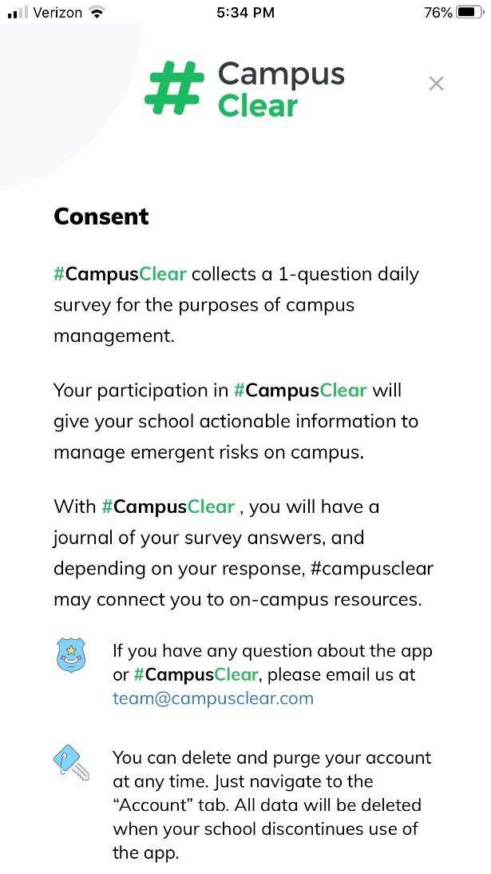
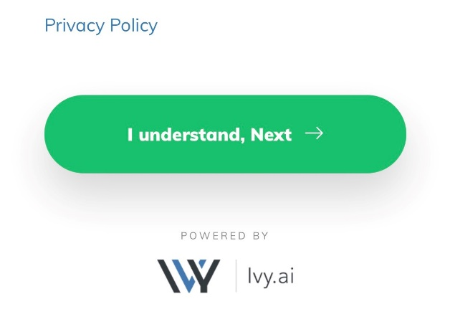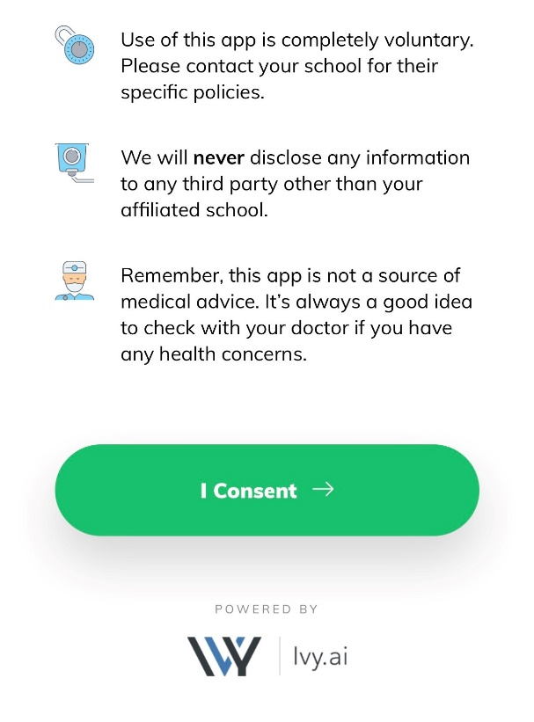

- If you are a Hood employee, please select the Employee box. Click Next.

If you are a Hood student, please select the Student box. Click Next.

If you are a Hood visitor (you do not have a Hood user account), please select the Visitor box. Click Next.

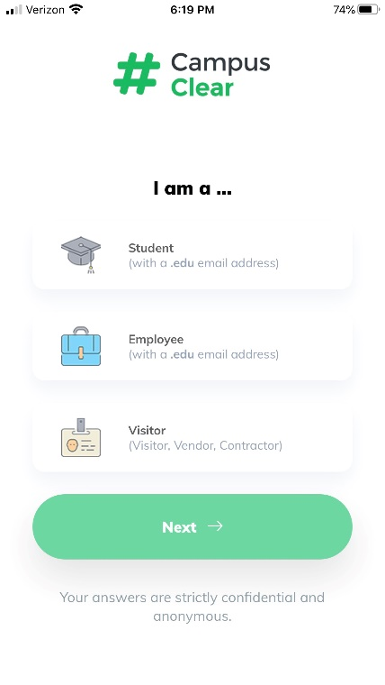

- Enter your chosen email address. Click Submit.

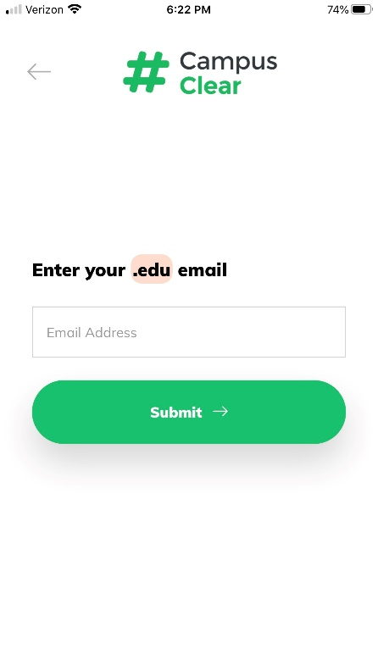
- You should receive a confirmation email in the email address specified.

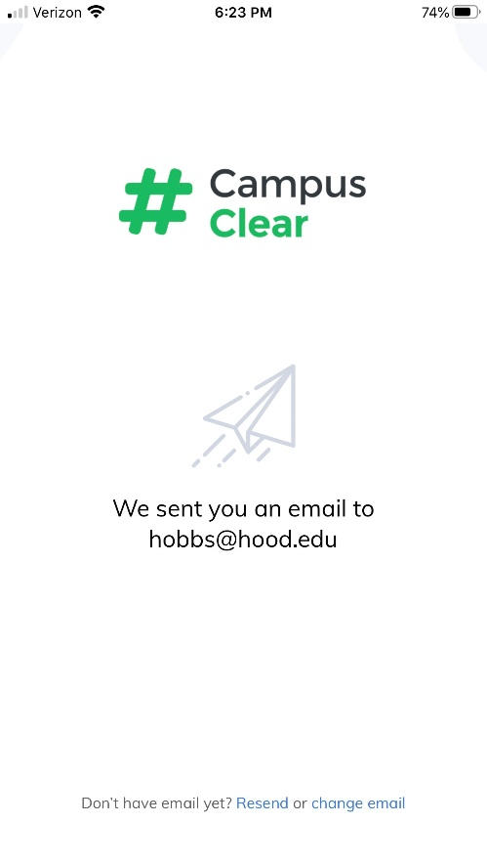
- Open the email and click “Confirm email” (see below).

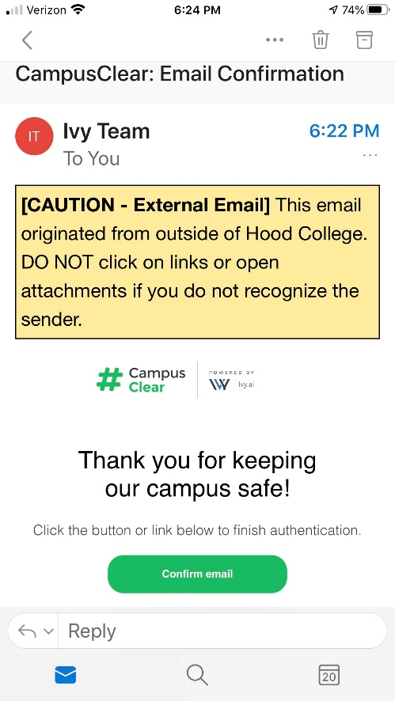
- You should receive a validation web page on your device. The Campus Clear App should now be available for you to use on your device.

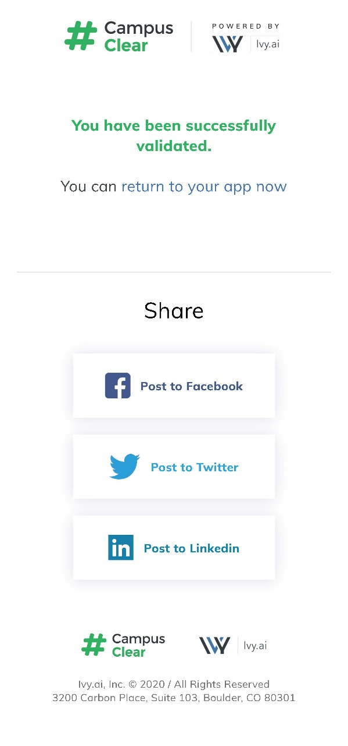

- Click Start to take your daily assessment.

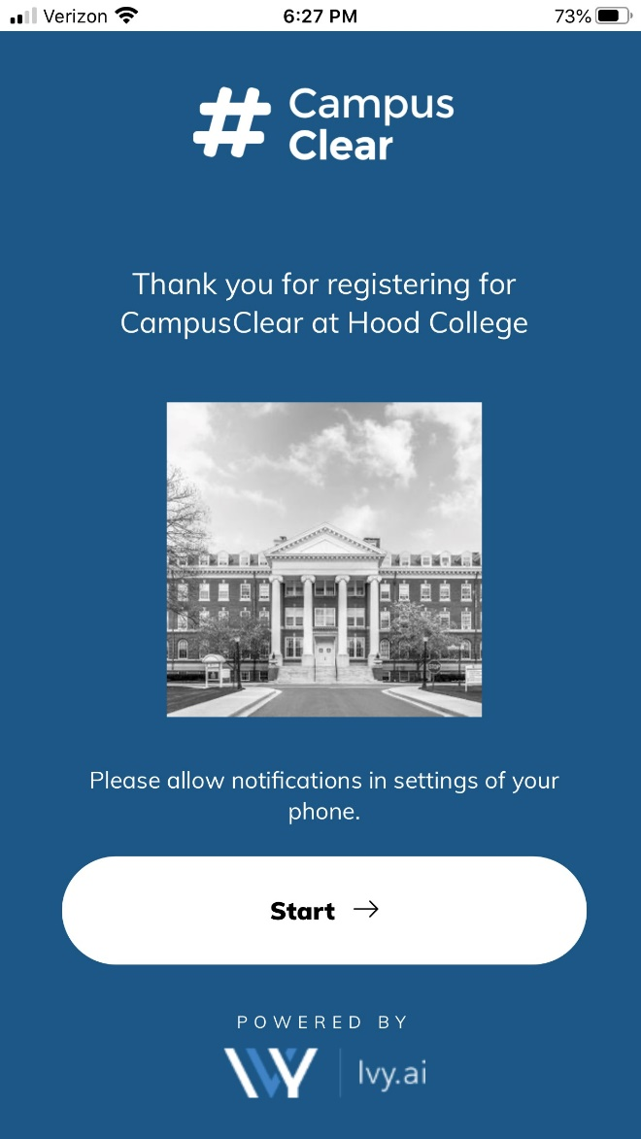

- Select all conditions that apply and click See Results.

For Web Browsers

- On your browser, click this link to install the Campus Clear App.

- Review the following terms and conditions.

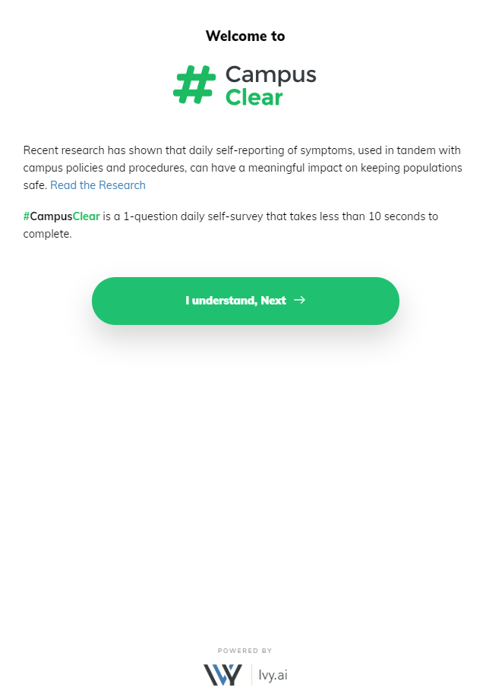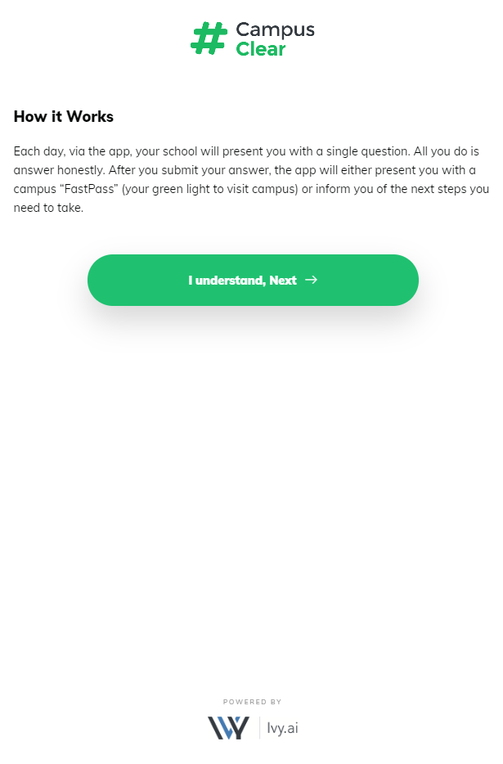

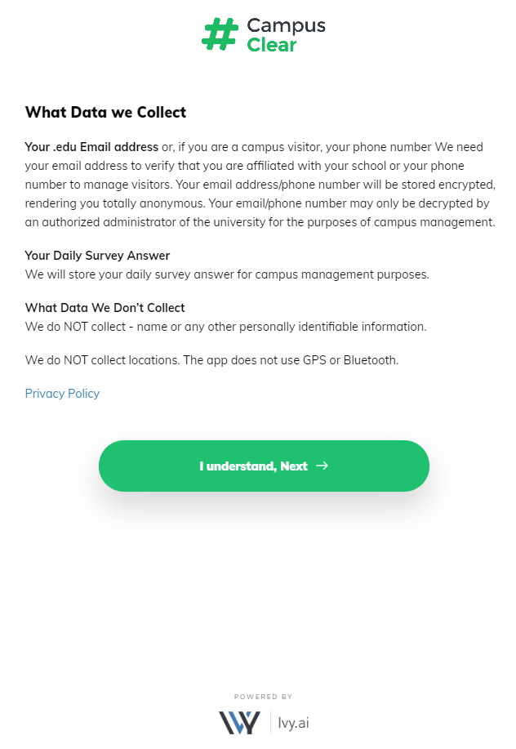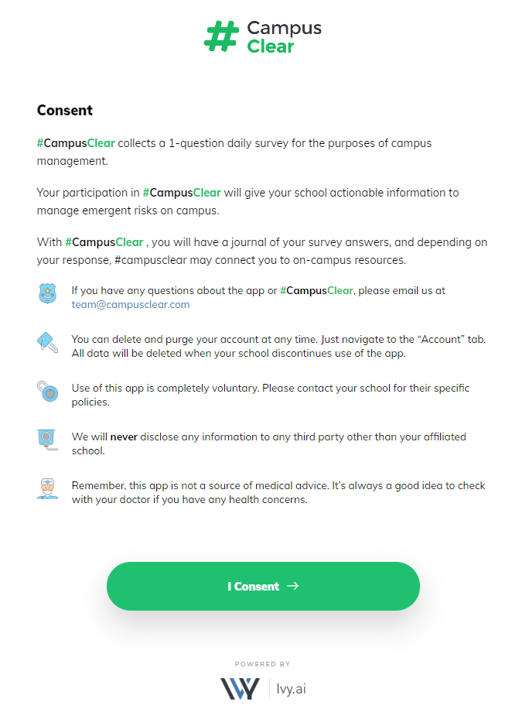
- If you are a Hood employee, please select the Employee box. Click Next.

If you are a Hood student, please select the Student box. Click Next.

If you are a Hood visitor (you do not have a Hood user account), please select the Visitor box. Click Next.

- Enter your chosen email address. Click Submit.

- You should receive a confirmation email in the email address specified.

- Open the email and click “Confirm email” (see below).

- You should receive a validation web page on your computer browser. The Campus Clear App should now be available for you to use on your computer.

- Click Start to take your daily assessment.

- Select all conditions that apply and click See Results.

